Image Processing

Contents

1. Introduction 3

2. Load and Convert to Grayscale 4

3. Noise Filtering 5

3.1. Mean Filtering 5

3.2. Median Filtering 6

4. Contrast Stretching 7

4.1. Linear Contrast Stretching 7

4.2. Power Law Contrast Stretching 8

5. Deblurring 9

5.1. Simple Deblurring 9

5.2. Wiener Deconvolution 10

5.3. Additional Operation 11

6. Histogram Analysis 12

7. Evaluation Metrics 13

7.1. Entropy 13

7.2. Signal-to-Noise Ratio (SNR) 13

8. Conclusion 13

# Introduction

This report outlines the process undertaken to enhance and analyze a given image through various image processing techniques. The primary objectives include reducing noise, improving contrast, and mitigating blurriness. The following sections elaborate on the specific steps involved and the outcomes achieved.

Step 1: Load and Convert to Grayscale

Step 2: Noise Filtering

Step 3: Contrast Stretching

Step 4: Deblurring

Step 5: Histogram Analysis

step 6: Evaluation Metrics

This is an input image.

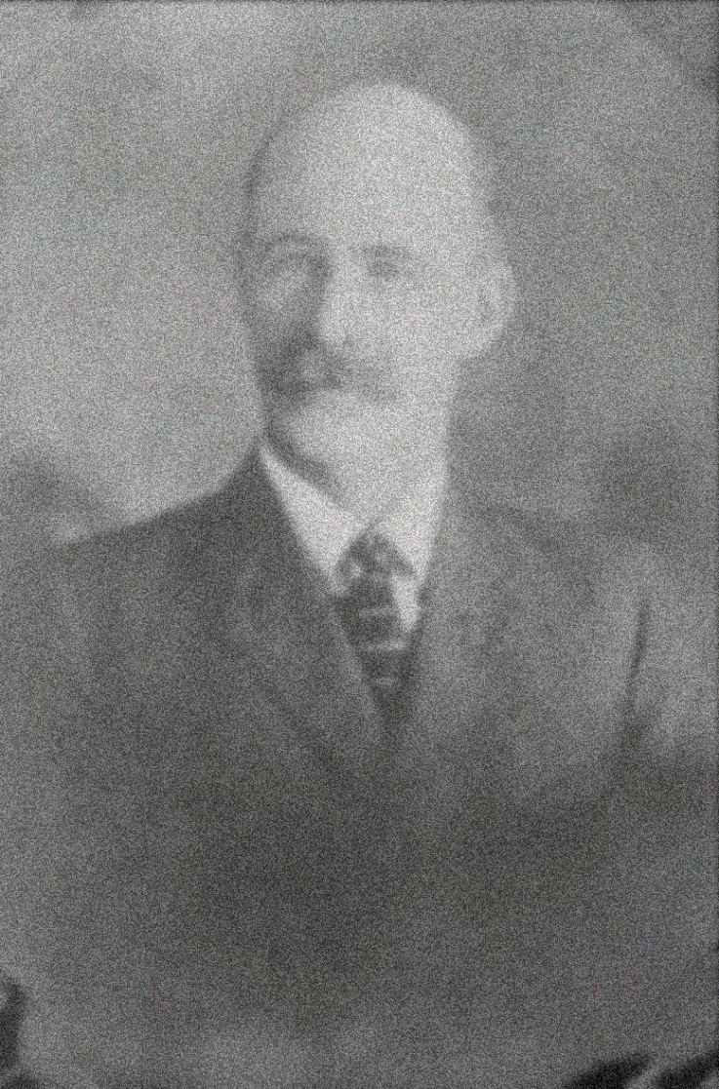

# Load and Convert to Grayscale

The initial step involved loading the original color image and converting it into grayscale. Grayscale conversion simplifies subsequent processing steps and facilitates a clearer focus on image details.

Grayscale Image

# Noise Filtering

## Mean Filtering

Mean filtering was applied to the grayscale image to diminish noise and create a smoother appearance. This technique calculates the average value of a pixel's neighborhood, effectively reducing high-frequency noise.

Mean Filtered Image

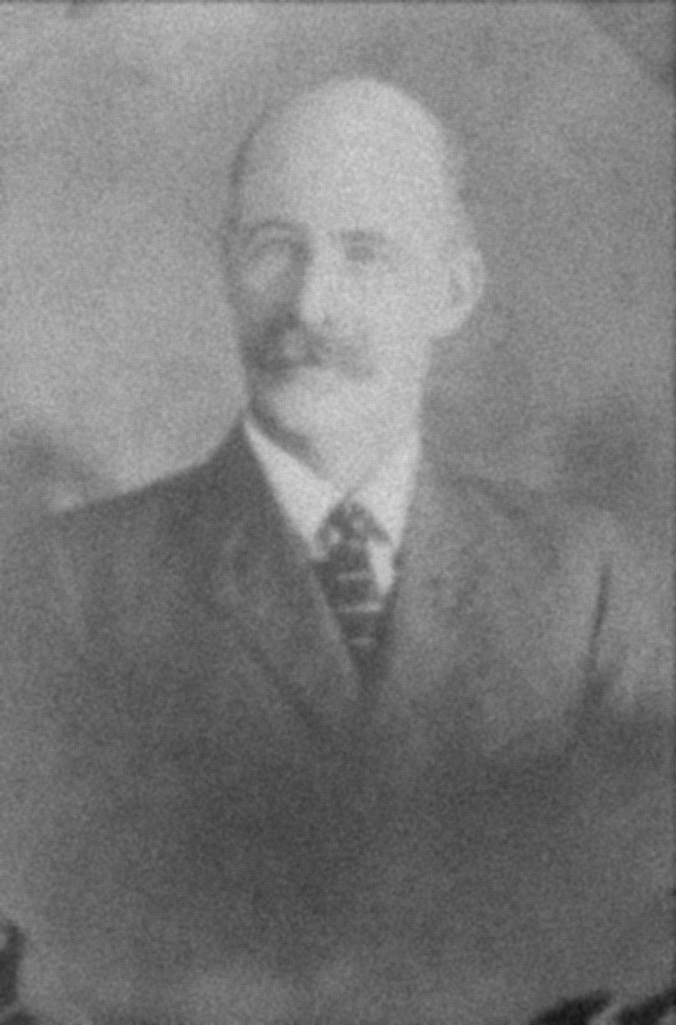

## Median Filtering

Median filtering, a non-linear technique, was subsequently employed to further suppress noise while preserving important image features. This method is particularly effective in eliminating salt-and-pepper noise.

Median Filtered Image

# Contrast Stretching

## Linear Contrast Stretching

Linear contrast stretching was utilized to enhance the overall contrast of the image. This method redistributes pixel intensities to span the entire available range, resulting in a visually more appealing image.

Linear Contrast Stretched Image

## Power Law Contrast Stretching

A power-law transformation was applied for further contrast adjustment. This method enhances the image by adjusting pixel intensities in a non-linear fashion, catering to specific visual preferences.

Power Law Contrast Stretched Image

# Deblurring

## Simple Deblurring

Simple deblurring was achieved through a kernel-based approach. The applied kernel enhances edges and sharpens details in the image.

Deblurred Image 1

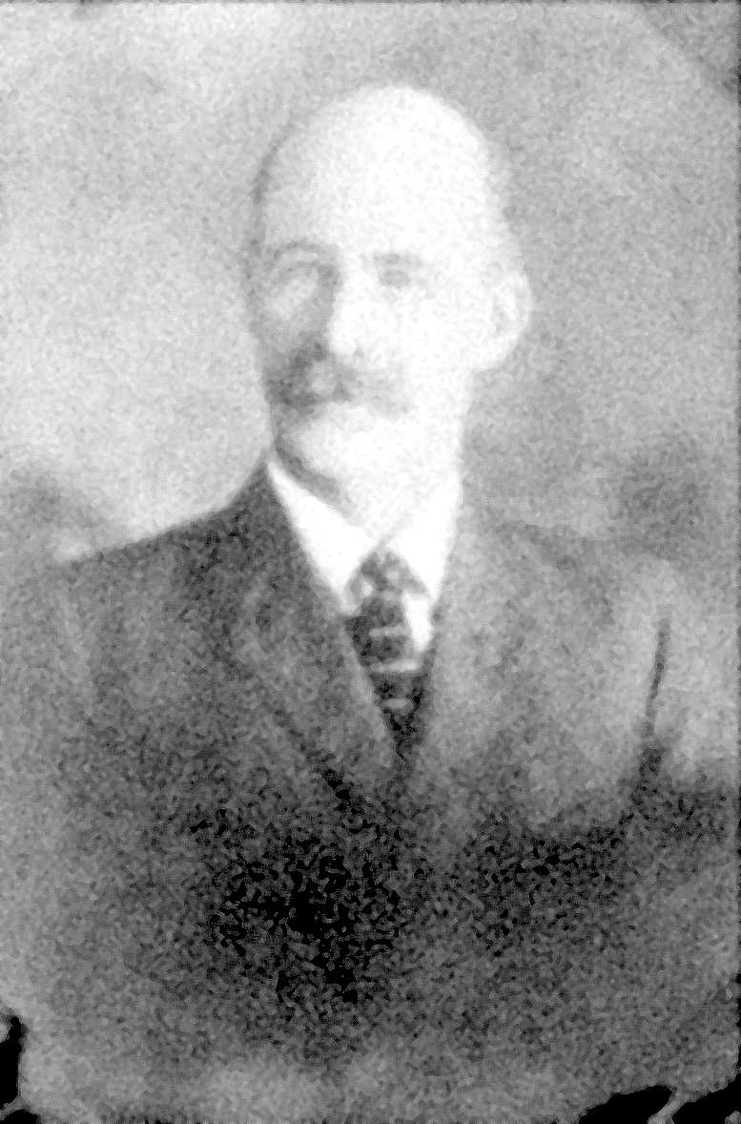

## Wiener Deconvolution

Wiener deconvolution, a more advanced technique, was employed to further improve image sharpness. This method is particularly effective in reducing blurriness caused by convolution with a point spread function.

Deblurred Image 2

## Additional Operation

Edges were extracted from the original image using Laplacian filtering. These edges were then added back to the deblurred image, resulting in enhanced details. The pixel values were clipped to ensure they fell within the valid intensity range [0, 255].

Enhance Image

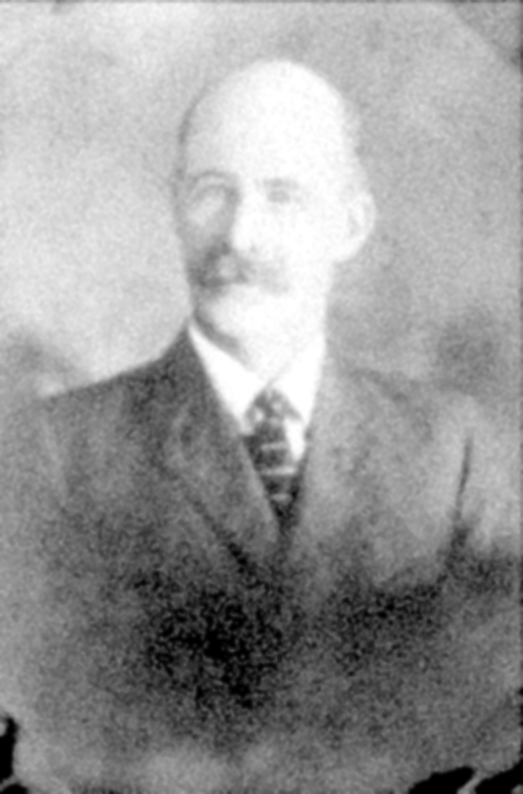

# Histogram Analysis

A histogram analysis was conducted to understand the distribution of pixel intensities in the final enhanced image. This visualization aids in assessing the overall tonal range and contrast.

Histogram

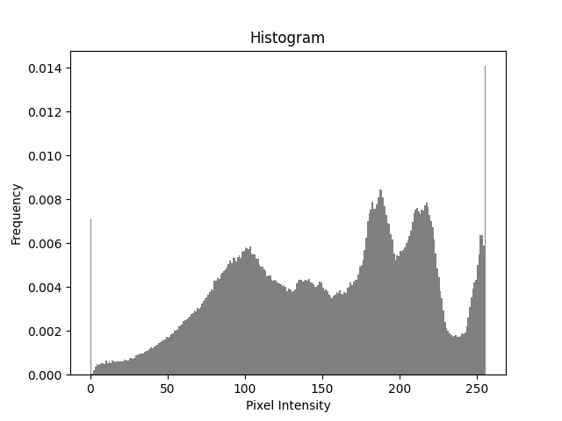

# Evaluation Metrics

## Entropy

Entropy, a measure of information content, was computed for the deblurred images. Higher entropy values indicate greater information content.

Entropy 1: 7.655536276849164

Entropy 2: 7.761989525722427

## Signal-to-Noise Ratio (SNR)

Signal-to-Noise Ratio (SNR) values were calculated to evaluate the quality of the deblurred images compared to the original grayscale image.

SNR 1: -0.17994364960107032

SNR 2: -0.17842930274137353

# Conclusion

In conclusion, the image processing pipeline successfully achieved the objectives of noise reduction, contrast enhancement, and deblurring. The combination of filtering, contrast stretching, and deblurring techniques resulted in a visually improved image with enhanced details and reduced artifacts.